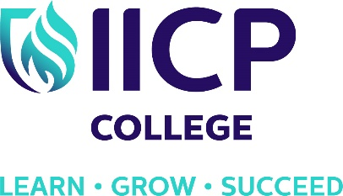
PROFESSIONAL KNOWLEDGE SEMINAR
PRESENTED BY
JOHN C. NORCROSS, Ph.D., ABPP
Thursday 4th APRIL 2019
IICP College is honoured and privileged to announce that the presenter of this year’s Professional Knowledge seminar is Dr. John Norcross, who is one of the world’s most prominent and influential leaders in the field of psychotherapy. Dr. Norcross is Distinguished Professor of Psychology at the University of Scranton, Adjunct Professor of Psychiatry at SUNY Upstate Medical University, and a board-certified Clinical Psychologist.
He has written over 400 publications and has co-written/edited 22 books on psychotherapy, psychotherapy integration, clinical psychology, professional training, supervision and self-change. Among them are: Psychotherapy Relationships that Work; Insider's Guide to Graduate School in Clinical & Counseling Psychology; APA Handbook of Clinical Psychology (5 volumes), and Systems of Psychotherapy (now in its 9th edition). He is co-editor of the Handbook of Psychotherapy Integration with Marvin R. Goldfried. This book is considered "the bible of the integration movement", providing a comprehensive, state-of-the-art description of therapeutic integration and its clinical practices by the leading proponents in the field.
Dr. Norcross is past-president of the American Psychological Association (APA) Division of Psychotherapy and the Division of Clinical Psychology as well as the Society for the Exploration of Psychotherapy Integration (SEPI). He has served as an APA Council Representative and as a director of the National Register of Health Service Psychologists.
Time: 10.00am to 4.30pm,
Venue: Green Isle Hotel, Clondalkin, Dublin 22
Cost: Early Bird special offer until 15th March: €90, €120 thereafter (IICP Alumni discount of 15%).
Tea, Coffee and Sandwiches will be provided for lunch.
More details will follow on learning outcomes and the format for the day. This notice is to allow people to Save the Date at this point. To reserve a place or for more information, contact IICP college on 01 4664205. Visit https://www.iicp.ie/cpdcourses/pkseminar2019/ for online booking which is now open.

