TURNING POINT™ INSTITUTE

23 HERBERT STREET, DUBLIN 2
Tel: 01 2801603
Web: www.turningpoint.ie
Email: admin@tpti.ie

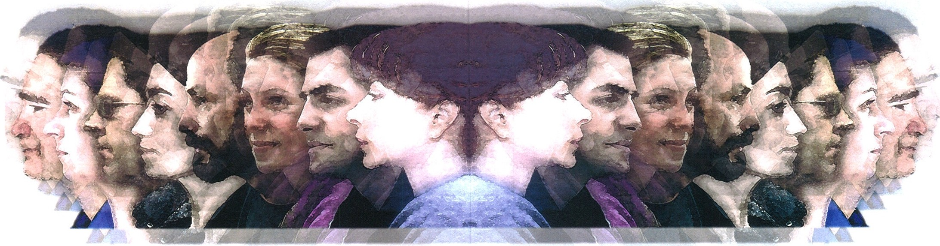
i'

Counselling and Psychotherapy for Individuals, Couples, Families and Groups
Grief Counselling and Psychotherapy Employee Assistance Programmes Meditation
Stress Management
Continuing Professional Development Programmes Supervision Training
Mindfulness
Leadership Training and Development
Foundation Course in Counselling and Psychotherapy
Professional Training in Integrative Counselling and
Psychotherapy

FOUNDATION COURSE IN COUNSELLING &PSYCHOTHERAPY

Part-time Certificate Course at

Turning Point™ Institute

Are you at a "turning point" in your life?
Do people, and what makes
them tick, fascinate you?
Are you a good listener?
Did you ever think of Counselling or Psychotherapy as a profession?

If your answer is yes to any or all of the above why not find out more about the counselling and psychotherapy profession by taking our Foundation Course in Counselling and Psychotherapy. This is a part time course, Tuesday evenings 7pm– 10pm

Themes:

What is Counselling/Psychotherapy
Historical background; overview of current theories; introduction to the skills of counselling and psychotherapy
Personality & Development
What is personality? Normal Adult Development Psychoanalysis
Classical Freud; the post-Freudians; Carl Jung
Cognitive-Behavioural Therapy
Skinner’s Behaviourism; The Cognitivists; Mindfulness Humanistic Psychotherapy Part 1and Part 2
Self-actualization; Carl Rogers and Person Centered Therapy; Gestalt
Transpersonal Psychotherapy
Links to Spirituality; Psychosynthesis
Systemic Psychotherapy
Family therapy; Group Work; Sociopolitical Context
Special Topics
Mental illness; Attachment; Grief and loss, Somatic Psychotherapy; Trauma; Positivity
The Practice of Psychotherapy
The Therapeutic Relationship; Transference/Counter-transference; Ethics, Professional Issues.

Learnings:
This course combines Academic/Theoretical and Experiential/Skills Practice components.
By the end of the course, participants will have:
Considered the range of psychotherapeutic
and counselling approaches that are currently available
in the field of psychotherapy, including a critical evaluation of each approach.
Explored many of the ethical concerns relevant to the field of Psychotherapy.
Found a deeper understanding of self and aspects of personal development on which a professional competence in the field of Psychotherapy is founded
Obtained information to facilitate them in making well-informed decisions about undertaking further professional training.

Facilitators:
All of the course facilitators are fully trained and accredited practicing psychotherapists.

Assessment and Award:
Evaluation is based on student's attendance and participation throughout the course. Students who complete the programme with satisfactory feedback from their tutor will receive a 'Foundation in Counselling and Psychotherapy' certificate from TPI.

Fee:
The fee for this course is €850. Credit card payment will be accepted. Application forms can be downloaded from our website at www.turningpoint.ie, or you can contact TPI by telephone on 01-2801603.

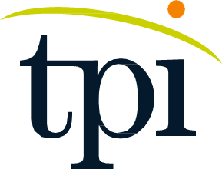Turning Point™ Institute reserves the right to make changes to dates, times and course content and will make every effort to advise participants of any such changes in good time.

